Supporting Online Lectures with Adaptive Features
¹ A. M. Riad, ² Hamdy K. El-Minir, ³ Haitham A. El-Ghareeb ^{* Corresponding Author}
^{1,3} Information Systems Department, Faculty of Computers and Information Sciences, Mansoura University, Egypt
Amriad2000@mans.edu.eg | helghareeb@acm.org
² Head of Communications Department, Higher Institution of Engineering, Misr Engineering and Technology Institute, Mansoura, Egypt
Hamdy_elminir2@yahoo.com

Abstract
This paper presents a proposed Adaptive Online Lecture Model that presents different pedagogical aspects for recommending the most suitable learning materials for students based on their learning profiles and preferences, involving students in the learning process from the very early beginning of the lecture, and preparing for the next/upcoming lecture, so students feel the personalization and customization of the lecture, and hopefully this model enhances the learning process and students’ online learning experience.

Introduction
The need for conducting and attending lectures in learning is clear for both students and instructors, and can be managed effectively and efficiently when both exist in the same place and on the same time; “Traditional Learning Model”. Situation differs when students and instructors are experiencing either time and/or place differences/distances. Here comes
“e-Learning” as the solution. Online meetings as a technology facilitate this objective by presenting the required audio and video communications between instructor and students side by side with the capability to share presentations, desktop activities, and transfer files. Different online meetings software and applications; in both Web and desktop forms are available, however their design and implementation was not aimed in the first place to be used for online lectures. Despite the tremendous advancement in technology that is witnessed by those applications, they still lack certain level of feedback from students to instructors that pushes students into more engagement within the learning process.

Current Widely Spread Technologies in Learning Institutions
Learning Management System (LMS) is used in handling and managing the learning process. LMS implements technologies that enable virtual/digital university, and/or personal learning environments. LMS features can be categorized into four sub systems which concerned with courses, exams, assessments, and collaborative features. LMS can be thought of as the integration of four sub systems; each presenting specific functionalities via specific tools (El-Ghareeb, 2009).
Service Oriented Architecture (SOA) as a design pattern that presents systems as collection of reusable services that can be exposed and consumed on the Internet with standard interfaces has many advantages that can be achieved on technical, managerial, and implementation aspects of the system. Integrating UMIS and LMS can be achieved effectively, efficiently, and with minor modifications of both systems via SOA utilization.

Video Conferencing Technologies in Learning Institutions
Video Conferencing Technologies when utilized in the learning process act as “isolated islands”, because activities done there are not recorded in students’ learning profiles. They are used exactly as presented by providers. Their design was not meant mainly for lecture purpose. Integration of activities conducted during online lectures and student learning profiles in LMS, and finding innovative ways for involving students deeply into lecture activities is a necessity.

Web 2.0 Technologies
Ever since group behavior became an important part of mainstream Web sites, companies have found numerous ways to exploit the behavior of Web surfers. Web 2.0 includes the many social networking Web sites that have tried to profit from the basic human need to connect with others. The Web 2.0 phenomenon is more rightly described as a social and behavioral sea change. Instead of serving up static fixed content to Web surfers, the Web has become an interactive place for people to congregate and do things together — virtually. Web 2.0 is about the way people use Web 1.0, not about the Web itself (Pollock, 2009). Web 2.0 refers to the social use of the Web which allow people to collaborate, to get actively involved in creating content, to generate knowledge and to share information online (Grosseck, 2009). Most instructors are fascinated with teaching and learning, so they are interested in utilizing whatever their hands reach to in enhancing and supporting the learning process. Web 2.0 technologies proposed to be utilized in the proposed Adaptive Online Lecture Model are utilized for getting indirect feedback, or to enhance collaboration.
- Formal Feedback Support Technologies “Assessments Enablers”: Conducting Assessments is an important learning activity that tends to estimate and measure students’ understandings of taught topics. Assessments shall go beyond such testing students’ ability of recalling data from their short/long memory to verifying students’ abilities to use the gained knowledge in an efficient manner; so they become knowledgeable about the learned topics. Bloom’s taxonomy addresses this issue in detail (Krathwohl, 2002). IMS defines 11 types of questions that can be supported electronically.
- Indirect Feedback Support Technologies: Status updates, blogging, and Micro-blogging are among Web 2.0 activities that today’s students are familiar with and repeat daily. The idea of allowing students to access different Web 2.0 technologies and communicate informally attempts to promote students to give indirect feedback that instructors can read thoroughly and check later, so instructor can abstract some points about the lecture to be made benefit of later at other lectures, or when giving the same lecture again. This way of feedback will encourage students to say what they think about and give the instructor deeper insights on the lecture.
- Collaborative Enabling Technologies: Web 2.0 facilitated different forms of online collaboration that can be used in assignments. Online Workspaces that can be used for file sharing, interactive and collaborative online documents editing, mind mapping and tools are examples of collaborative online Web 2.0 technologies that can be used collaboratively as assignments tools.

Pedagogical Aspects of Proposed Adaptive Online Lecture Model
Preparing lecture is one of the instructor’s responsibilities that can be enhanced via utilizing new technologies. Different types of learning objects (LOs) media and formats exist, and the Web has turned into an open source for knowledge and sharing. While instructor has access to an enormous diversity of LOs, recommending LO over another can be helpful for instructor. This recommendation process needs to take place before the lecture “while instructor is preparing the lecture” based on students’ learning profiles and preferences, thus students becomes more attached to the lecture.
Engaging students in the lecture activities will enhance students learning experience. Technically, this is available via extensive utilization of technologies that exist nowadays. During the online lecture, students are encouraged to give continuous informal feedback about different lecture activities via the same Web 2.0 technologies they are used to. This feedback can be studied and analyzed later by instructor, and used as an indicator on how the lecture was moving, then utilized in enhancing the upcoming lectures. Formal feedback request can be initiated by instructor from time to time to test certain points that instructor needs to assure about; as a “check point” before moving on with the next lecture. Involving students in different assignments and activities during the lecture is welcomed, and needs to be recorded in students learning profiles.
Finally, preparing for the next/upcoming lecture is not only instructor’s responsibility. Pedagogically, instructor is supposed to define the upcoming lecture topics, and pre-requisites for learning those topics. Technically, LMS is supposed to check student’s learning profile and preferences to define to what extent student is familiar with those topics or not, then recommending the learning materials for student. It is student’s responsibility to study and examine those learning materials before next lecture.

Phase One: Preparing the Lecture
Students' learning models are not the same, and that shall be considered while preparing and choosing the contents to be displayed during Online Lecture. In order not to lose student during the lecture, types of contents shall be mapped with both their direct feedback and learning profiles. Figure 1 presents the different activities required to fulfill this process.
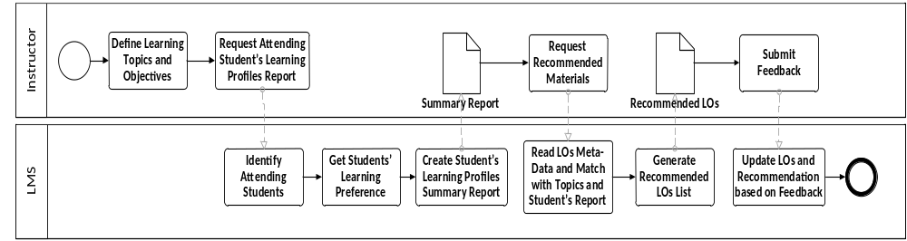
Figure 1: Recommend LOs for Instructor based on Analysis of Learning Profiles Process

Phase Two: During Online Lecture
Proposed Adaptive Online Lecture Model attempts to address different lecture aspects that are not available in current Video Conference Model. Those aspects are: Order of Contents, Assessments, and Assignments and Collaborative activities.
- Order of Contents: Displaying the video file before talking about it, or after talking about it or twice in the lecture is one of the decisions that instructors might not pay much attention to while it is important in keeping students focused on lecture activities. If students’ are given some capability to re-order the contents’ display and discussions, they will feel the personalization of the Online Lecture, and so deeply get involved in the lecture.
- Assessments: Instructors might need to conduct one of the on-the-fly assessments to ensure that students have reached a basic level of knowledge regarding one of the topics s/he was just talking about before moving to the next topic.
- Assignments and Collaboration: Students attending online lectures are already connected to the Internet via their laptops, have accounts on multiple Web 2.0 collaboration tools providers; like Microsoft and Google, so they can easily transform to those tools based on instructor’s directions. Their collaborative work can be marked, and discussed online as if they are in a traditional lecture.
Figure 2 presents the proposed Activity Diagram of the During Lecture activities that will allow students to submit informal feedback during the lecture. This feedback will be analyzed later by the instructor.
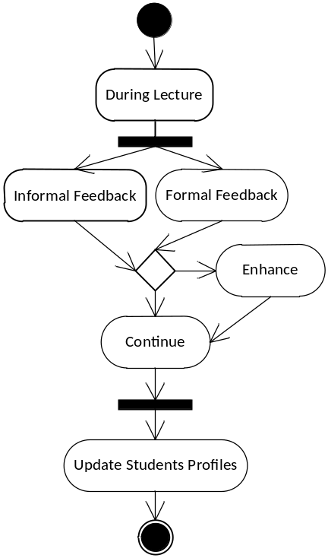
Figure 2: Formal and Informal Feedback Processes Synchronization During Lecture

Phase Three: Upcoming Lecture
Identifying Next Lecture Topics based on Students' Learning Profiles and Feedback is one of the proposed Adaptive Online Lecture Model activities. Before Students leave current lecture, instructors shall ensure that they are familiar with the prerequisites of the upcoming lecture. Proposed Adaptive Online Lecture can facilitate so by conducting assessments from students and ask them clearly about the prerequisites. Besides, Proposed Adaptive Online Lecture Model is part of the learning institution and an important piece of enhancing the learning process. So, Proposed Adaptive Online Lecture Model can access the Student Profile and Online Preferences for data about their previous attended sessions, courses, specifications, and other details. In case one of the students doesn't satisfy requirements defined by instructor, a personalized content can be generated for that student via Intelligent Learning Objects (LOs) Recommender, and Student's interaction with those materials is tracked. Figure 3 presents the different system’s activities to support the adaptive LOs recommendation.
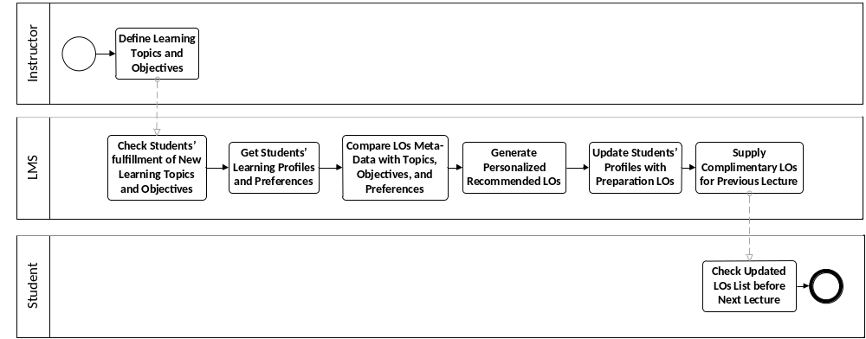
Figure 3: Recommend LOs for Students based on Upcoming Lecture Topics and their Preferences

Technical Aspects of Proposed Adaptive Online Lecture Model

Proposed IT Architecture to Support Proposed Adaptive Online Lecture Model
Figure 4 presents a proposed IT architecture to support proposed adaptive online lecture model. Educational institutions differentiate between different components required to support the learning process, and are familiar with some technologies like UMIS and LMS. IT Architecture includes the following servers list:
- Firewall: The system’s entry point and responsible for providing security functions.
- Active Directory (LDAP): A Single Log-in point for the entire system. Helps avoid the repeated Log-in process between different applications and servers.
- Collaboration, Assessments, and Assignments: Main components of the Learning Process that are maintained separately to provide greater flexibility and the ability to utilize different technologies.
- Students Data, Student Preferences, Learning Profiles: Main asset of LMS that maintains students’ data to be utilized by different applications. Adaptive Online Lecture Model relies heavily on those data to present personalized recommendations.
- Course Specifications and Instructors Data: Data about Instructors and Courses are stored to enable automation of the communications between Course Management Systems (CMSs) and Recommenders.
- Real-time Communication Server: Responsible for providing communications functionalities between instructors and students, and students and each other. Manages Online Lecture file, desktop, text sharing, other activities, and Web 2.0 technologies that will be utilized in the Informal Feedback.
- Analyzer and Report Generator: Responsible for analyzing gathered data and generating appropriate reports that help instructors take the appropriate decision.
- Middleware: Responsible for managing Quality of Service (QoS) and directing messages between different components of the systems.
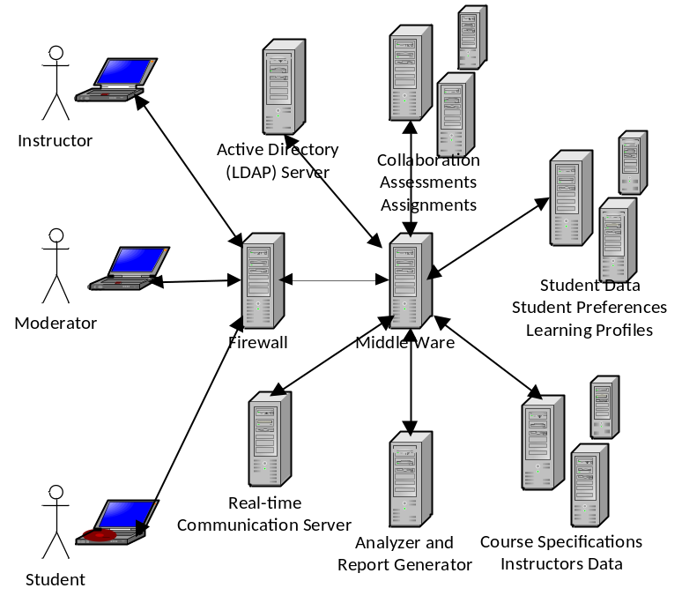
Figure 4: Proposed Adaptive Online Lecture Model IT Architecture

Conclusion and Future Work
This paper presented a proposed Adaptive Online Lecture Model that tends to utilize different technologies available to educational institutions, instructors, and students in an innovative way to provide deeper communication between instructors and students during online sessions needed to support e-Learning. Web 2.0 technologies enriched both instructors' and students’ lives with contents generated by Internet users, and the ability to provide real-time feedback, among other many different capabilities. Software Architecture and IT Infra Structure Architecture required to enable proposed adaptive online lecture model is presented, highlighting different challenges and presenting solutions for them.

References
El-Ghareeb, H. A. (2009). E-Learning and Management Information Systems: Universities Need Both. eLearn Magazine, ACM, Retrieved October 28, 2009 from http://elearnmag.org/subpage.cfm?section=articles&article=96-1
Grosseck, G. (2009). To use or not to use web 2.0 in higher education? World Conference on Educational Sciences, - New Trends and Issues in Educational Sciences. Volume 1, Issue 1, El-Sevier, Nicosia, North Cyprus.
Krathwohl, D. R. (2002). A Revision of Bloom’s Taxonomy: An Overview. Theory Into Practice, Volume 41, Number 4. College of Education, The Ohio State University
Pollock, J. T. (2009). Semantic Web for Dummies. Wiley Publishing Inc.

